<https://byjus.com/physics/hypothesis/>

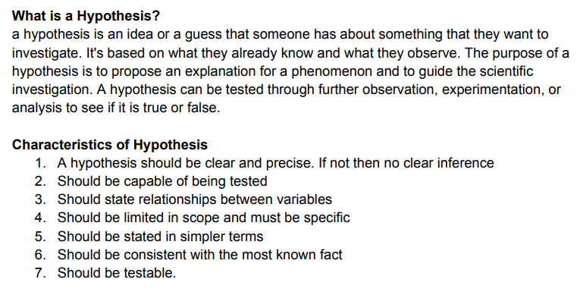

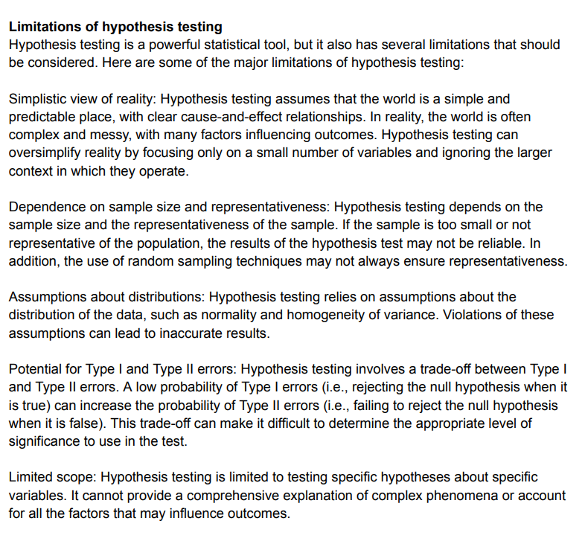

What is Hypothesis Testing?

Hypothesis testing in statistics refers to analyzing an assumption about a population parameter. It is used to make an educated guess about an assumption using statistics.

With the use of sample data, hypothesis testing makes an assumption about how true the assumption is for the entire population from where the sample is being taken.

Any hypothetical statement we make may or may not be valid, and it is then our responsibility to provide evidence for its possibility.

To approach any hypothesis, we follow these four simple steps that test its validity.

1. First, we formulate two hypothetical statements such that only one of them is true. By doing so, we can check the validity of our own hypothesis.
2. The next step is to formulate the statistical analysis to be followed based upon the data points.
3. Then we analyze the given data using our methodology.
4. The final step is to analyze the result and judge whether the null hypothesis will be rejected or accepted.

Hypothesis testing provides various techniques to test the hypothesis statement depending upon the variable and the data points. It finds its use in almost every field of research while answering statements such as whether this new medicine will work, a new testing method is appropriate, or if the outcomes of a random experiment are probable or not.

Example:

It is observed that the average recovery time for a knee-surgery patient is 8 weeks. A physician believes that after successful knee surgery if the patient goes for physical therapy twice a week rather than thrice a week, the recovery period will be longer. Conduct hypothesis for this statement.

To find the validity of any statement, we have to strictly follow the stepwise procedure of hypothesis testing. After stating the initial hypothesis, we have to re-write them in the form of a null and alternate hypothesis.

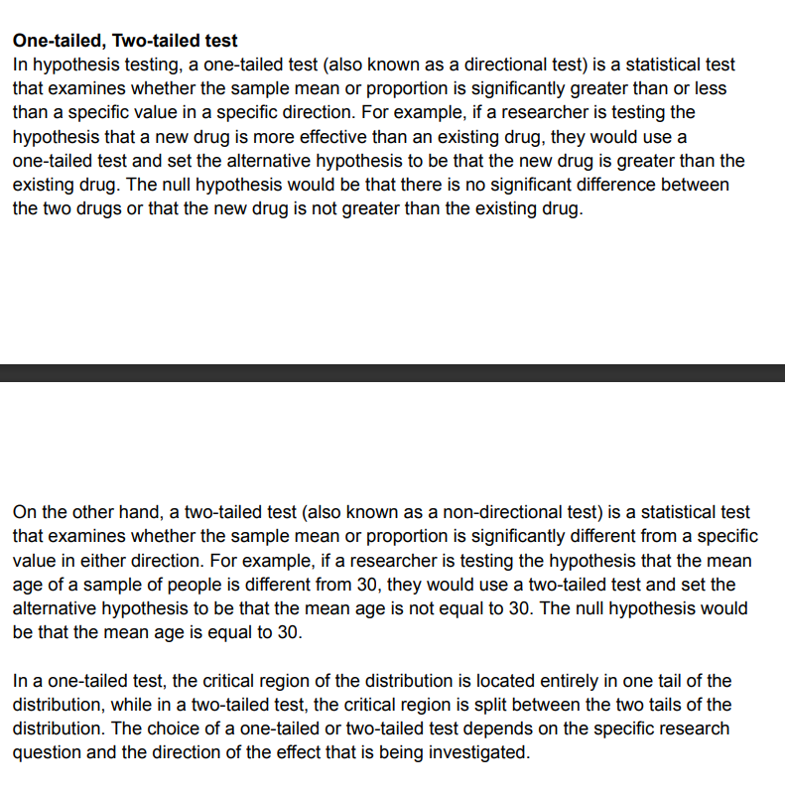

NULL HYPOTHESIS:

In statistics, the null hypothesis refers to a statement or assumption that suggests there is no significant difference or relationship between two or more variables in a population.

It is often denoted as H₀.

The null hypothesis is used in hypothesis testing, where it serves as a starting point for statistical analysis. It represents the position of skepticism or no effect, and the goal is to either reject or accept the null hypothesis based on the available evidence.

The formula for the null hypothesis is:

H0: p = p0

For example, let's say you are conducting a study to determine whether a new drug is effective in treating a particular disease. The null hypothesis in this case might be that the drug has no effect and is not different from a placebo. The alternative hypothesis, on the other hand, would state that the drug does have an effect.

Through statistical analysis, you would collect data, perform calculations, and compare the results to determine whether there is sufficient evidence to reject the null hypothesis in favor of the alternative hypothesis. If the evidence is strong enough, you would reject the null hypothesis, suggesting that there is a significant difference or relationship between the variables being studied.

When written in mathematical terms, they always include an equality (usually =, but sometimes ≥ or ≤).

When you incorrectly reject the null hypothesis, it’s called a type I error. When you incorrectly fail to reject it, it’s a type II error.

Developing a null hypothesis involves formulating a statement that assumes there is no significant difference or relationship between variables. Here's a step-by-step guide on how to develop a null hypothesis:

**Identify the variables:** Determine the variables you want to study or compare. These could be two groups, two measurements, or two factors that you suspect may be related.

**Define the nature of the relationship:** Decide whether you are looking for a difference between groups, a correlation between variables, or a comparison between conditions.

**State the null hypothesis:** Formulate a statement that suggests there is no significant difference or relationship between the variables. Typically, the null hypothesis assumes no effect, no correlation, or no difference between groups. The null hypothesis is often denoted as H₀.

**Be specific and testable:** Ensure that your null hypothesis is specific and testable. It should clearly state the absence of an effect or difference. Avoid vague or ambiguous statements that cannot be measured or tested.

**Consider the statistical test:** Based on the nature of your study and variables, consider the appropriate statistical test to evaluate your null hypothesis. Different tests exist for different types of data and research questions.

**Formulate the alternative hypothesis:** Alongside the null hypothesis, develop an alternative hypothesis (often denoted as H₁ or Ha) that states there is a significant difference or relationship between the variables. The alternative hypothesis is what you hope to demonstrate if the evidence supports it.

**Collect and analyze data:** Gather data related to your variables and perform the chosen statistical test. The test will provide results that either support or refute the null hypothesis.

**Interpret the results:** Based on the analysis, determine whether you have enough evidence to reject the null hypothesis. If the evidence is strong enough, you may reject the null hypothesis and support the alternative hypothesis. If the evidence is not sufficient, you fail to reject the null hypothesis.

ALTERNATIVE HYPOTHESIS:

The alternative hypothesis, often denoted as H₁ or Ha, is a statement that contradicts or opposes the null hypothesis in a statistical analysis. It represents the proposition or claim that there is a significant difference, effect, or relationship between variables being studied.

While the null hypothesis assumes no effect or no difference, the alternative hypothesis suggests otherwise. It states the presence of a relationship, effect, or difference that is being investigated or hypothesized.

Basically, there are three types of the alternative hypothesis, they are;

**Left-Tailed:** Here, it is expected that the sample proportion (π) is less than a specified value which is denoted by π0, such that;

H1 : π < π0

**Right-Tailed:** It represents that the sample proportion (π) is greater than some value, denoted by π0.

H1 : π > π0

**Two-Tailed:** According to this hypothesis, the sample proportion (denoted by π) is not equal to a specific value which is represented by π0.

H1 : π ≠ π0

Developing an alternative hypothesis involves formulating a statement that proposes a significant difference, effect, or relationship between variables. Here's a step-by-step guide on how to develop an alternative hypothesis:

**Understand the research question:** Clearly define the research question or the phenomenon you are investigating. Identify the variables of interest and the nature of the relationship you suspect may exist between them.

**Consider the null hypothesis:** Review the null hypothesis that assumes no significant difference or relationship. The alternative hypothesis should oppose or contradict the null hypothesis.

**Determine the directionality:** Decide whether you expect the relationship or difference to be one-tailed (directional) or two-tailed (non-directional). A one-tailed hypothesis specifies the expected direction of the effect, while a two-tailed hypothesis allows for differences in either direction.

**State the alternative hypothesis:** Develop a statement that suggests a significant difference, effect, or relationship between the variables. Be clear, specific, and precise in formulating the alternative hypothesis. It should directly address the research question and align with the expected directionality.

**Ensure testability and measurability:** Make sure that your alternative hypothesis is testable and can be evaluated using empirical data. It should be framed in a way that allows for statistical analysis and comparison with the null hypothesis.

**Consider the level of significance:** Determine the level of significance or alpha value you will use to evaluate the alternative hypothesis. This helps determine the threshold for considering the evidence as significant.

**Combine with the null hypothesis:** Remember that the alternative hypothesis and null hypothesis are complementary statements. Together, they encompass the possible outcomes of the statistical analysis. While the alternative hypothesis proposes a significant difference, effect, or relationship, the null hypothesis assumes the absence of such a difference or relationship.

**Collect and analyze data:** Gather relevant data and perform the appropriate statistical test to evaluate the alternative hypothesis. The test results will provide evidence to either support or reject the alternative hypothesis.

Type I error

A Type I error means rejecting the null hypothesis when it’s actually true. It means concluding that results are statistically significant when, in reality, they came about purely by chance or because of unrelated factors.

The risk of committing this error is the significance level (alpha or α) you choose. That’s a value that you set at the beginning of your study to assess the statistical probability of obtaining your results (p value).

The significance level is usually set at 0.05 or 5%. This means that your results only have a 5% chance of occurring, or less, if the null hypothesis is actually true.

If the p value of your test is lower than the significance level, it means your results are statistically significant and consistent with the alternative hypothesis. If your p value is higher than the significance level, then your results are considered statistically non-significant.

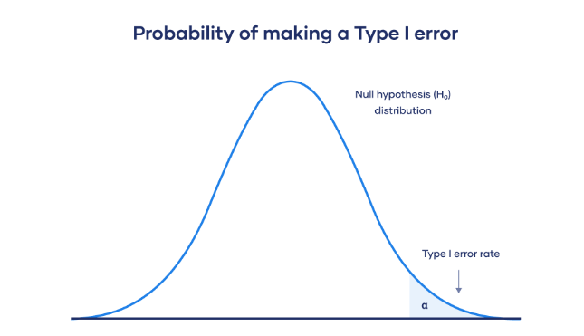

At the tail end, the shaded area represents alpha. It’s also called a critical region in statistics.

Type II error

A Type II error means not rejecting the null hypothesis when it’s actually false. This is not quite the same as “accepting” the null hypothesis, because hypothesis testing can only tell you whether to reject the null hypothesis.

Instead, a Type II error means failing to conclude there was an effect when there actually was. In reality, your study may not have had enough statistical power to detect an effect of a certain size.

Power is the extent to which a test can correctly detect a real effect when there is one. A power level of 80% or higher is usually considered acceptable.

The risk of a Type II error is inversely related to the statistical power of a study. The higher the statistical power, the lower the probability of making a Type II error.

Statistical power is determined by:

Size of the effect: Larger effects are more easily detected.

Measurement error: Systematic and random errors in recorded data reduce power.

Sample size: Larger samples reduce sampling error and increase power.

Significance level: Increasing the significance level increases power.

To (indirectly) reduce the risk of a Type II error, you can increase the sample size or the significance level.

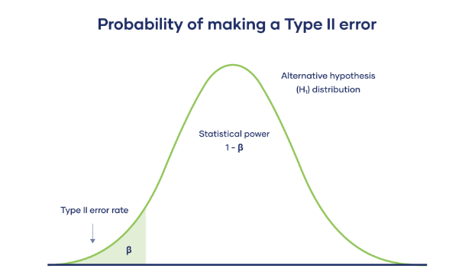

The Type II error rate is beta (β), represented by the shaded area on the left side. The remaining area under the curve represents statistical power, which is 1 – β.

Increasing the statistical power of your test directly decreases the risk of making a Type II error.

CHI-SQUARE GOODNESS OF FIT  
The Chi-square goodness of fit test is a statistical hypothesis test used to determine whether a variable is likely to come from a specified distribution or not. It is often used to evaluate whether sample data is representative of the full population.

You can use the test when you have counts of values for a categorical variable.

The Chi-square goodness of fit test checks whether your sample data is likely to be from a specific theoretical distribution. We have a set of data values, and an idea about how the data values are distributed. The test gives us a way to decide if the data values have a “good enough” fit to our idea, or if our idea is questionable.

There are two types of Pearson’s chi-square tests:

The chi-square goodness of fit test is used to test whether the frequency distribution of a categorical variable is different from your expectations.

The chi-square test of independence is used to test whether two categorical variables are related to each other.

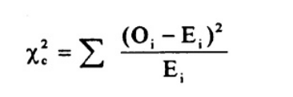

Where:

Χ2 is the chi-square test statistic

Σ is the summation operator (it means “take the sum of”)

O is the observed frequency

E is the expected frequency

<https://www.scribbr.com/statistics/chi-square-tests/#:~:text=The%20chi%2Dsquare%20goodness%20of,are%20related%20to%20each%20other>.

Tests of goodness of fit are statistical procedures used to assess how well an observed set of data fits a theoretical or expected distribution. These tests help determine if the observed data significantly deviates from the expected distribution, suggesting that the observed data may not be generated from the assumed theoretical distribution. Here are a few commonly used tests of goodness of fit:

**Chi-square goodness of fit test:** This test is used when comparing observed data with an expected distribution. It calculates the chi-square statistic by comparing the observed frequencies with the expected frequencies under the null hypothesis of no difference between the observed and expected distributions. The chi-square statistic follows a chi-square distribution, and p-value is used to determine the statistical significance of the difference.

Kolmogorov-Smirnov test: The Kolmogorov-Smirnov (KS) test is used to compare the observed data with a specified theoretical distribution. It calculates the maximum vertical distance (D) between the empirical distribution function of the observed data and the cumulative distribution function of the theoretical distribution. The KS test statistic follows a known distribution, and a p-value is used to assess the fit.

Anderson-Darling test: The Anderson-Darling (AD) test is a modification of the KS test that places more weight on the tails of the distribution. It considers the squared differences between the observed and expected cumulative distribution functions. The AD test statistic is compared to critical values from a known distribution, and a p-value is used to assess the goodness of fit.

Lilliefors test: The Lilliefors test is a modification of the KS test used to test the fit of the data to a normal distribution. It follows a similar procedure to the KS test but with modified critical values specific to the normal distribution.

REST SUMS REST SUMS REST SUMS REST SUMS REST SUMS REST SUMS REST SUM

OKOKOKOKO